**INDEX**

|  |  |  |
| --- | --- | --- |
| **Sr. No.** | **Contents** | **Page No.** |
| **Chapter 1** | **INTRODUCTION** |  |
| 1.1 Existing System | 2 |
| 1.2 Problem Definition- Need of Computerization | 2 |
| **Chapter 2** | **PROPOSED SYSTEM** |  |
| 2.1 Proposed System | 3 |
| 2.2 Objective of the System | 3 |
| 2.3 User Requirements | 4 |
| 2.4 Operating Environment – Hardware and Software | 4 |
| **Chapter 3** | **ANALYSIS AND DESIGN** |  |
| 3.1 Module List | 5 |
| 3.2 ERD, UML Diagram (respective diagrams) | 5 |
| 3.3 Table Design | 9 |
| 3.4 Screen Shots (Old And New) | 12 |
| **Chapter 4** | **USER MANUAL** |  |
| 4.1 User Manual | 18 |
| **Chapter 5** | **CONCLUSION** |  |
| 5.1 Future Enhancement | 19 |
| 5.2 Disadvantages | 19 |
| 5.3 Conclusion | 19 |

**Chapter 1**

* 1. **Existing System**

The existing system in this sector is mostly a “khaata book” based system which leads to heaps of space getting used for book storage and a tardy system.

It is a tedious job to maintain the record for the user since the human effort is more here. The retrieval of the information is not as easy as the records are maintained in the handwritten registers.

Various records are lost in this type of a system and are only accessible for a limited period of time after which they need to be replaced with a new record book.

The existing system is slower and time consuming and needs to be updated according to the needs of the users.

* 1. **Problem Definition – Need of Computerization**

After analyzing many existing Slogger we have now the obvious vision of the project to be developed. Before we started to build the application team had many challenges.

We defined our problem statement as:

➢ To make desktop/mobile based application Slogger for small organization.

➢ To make the system easily managed and accessible.

➢ To cover all the areas of Slogger like service details, sales details and stock

management.

**Chapter 2**

**2.1 Proposed System**

With the Digital India initiative every person has a smartphone in their pockets which they are already comfortable with. Our application just gives the users the ease of access to effortlessly carry out their daily tasks in a fraction of the time taken before.

Advantages of Proposed System:

* It is trouble-free to use
* It is a relatively fast approach to manage services
* It is highly reliable
* Easy to use interface
* Faster access
* More Storage
* Time efficient

**2.2 Objective of the System**

The objective of this system are mentioned below:

➢ To develop an application that deals with the day to day requirement of any production organization.

➢ To handle the inventory easily and quickly

➢ To handle the service details like customer details and repair details.

➢ To provide competitive advantage to the organization.

➢ To make the service manageable and simplify the use of inventory in the

organization.

**2.3 User Requirements**

End-user features that facilitate the reliability on Slogger might include the following:

* Storage of previous and ongoing service records
* The user should be able to provide real-time service updates to the consumer through text
* Ease the workload on users

**2.4 Operating Environment – Hardware and Software**

Software Specifications:

* Windows 10
* Android/IOS
* SQL Server 2019
* Visual Studio 2019
* HTML, JavaScript, PHP

Hardware Specifications:

* 16 GB HDD
* 2 GB RAM
* Entry level processor

**Chapter 3**

**3.1 Module List**

* Management Login on ERP
* New Service Entry
* Ongoing Services
* Service Completion
* Service Records

**3.2 ERD, UML Diagrams**

* Entity-Relationship Diagram

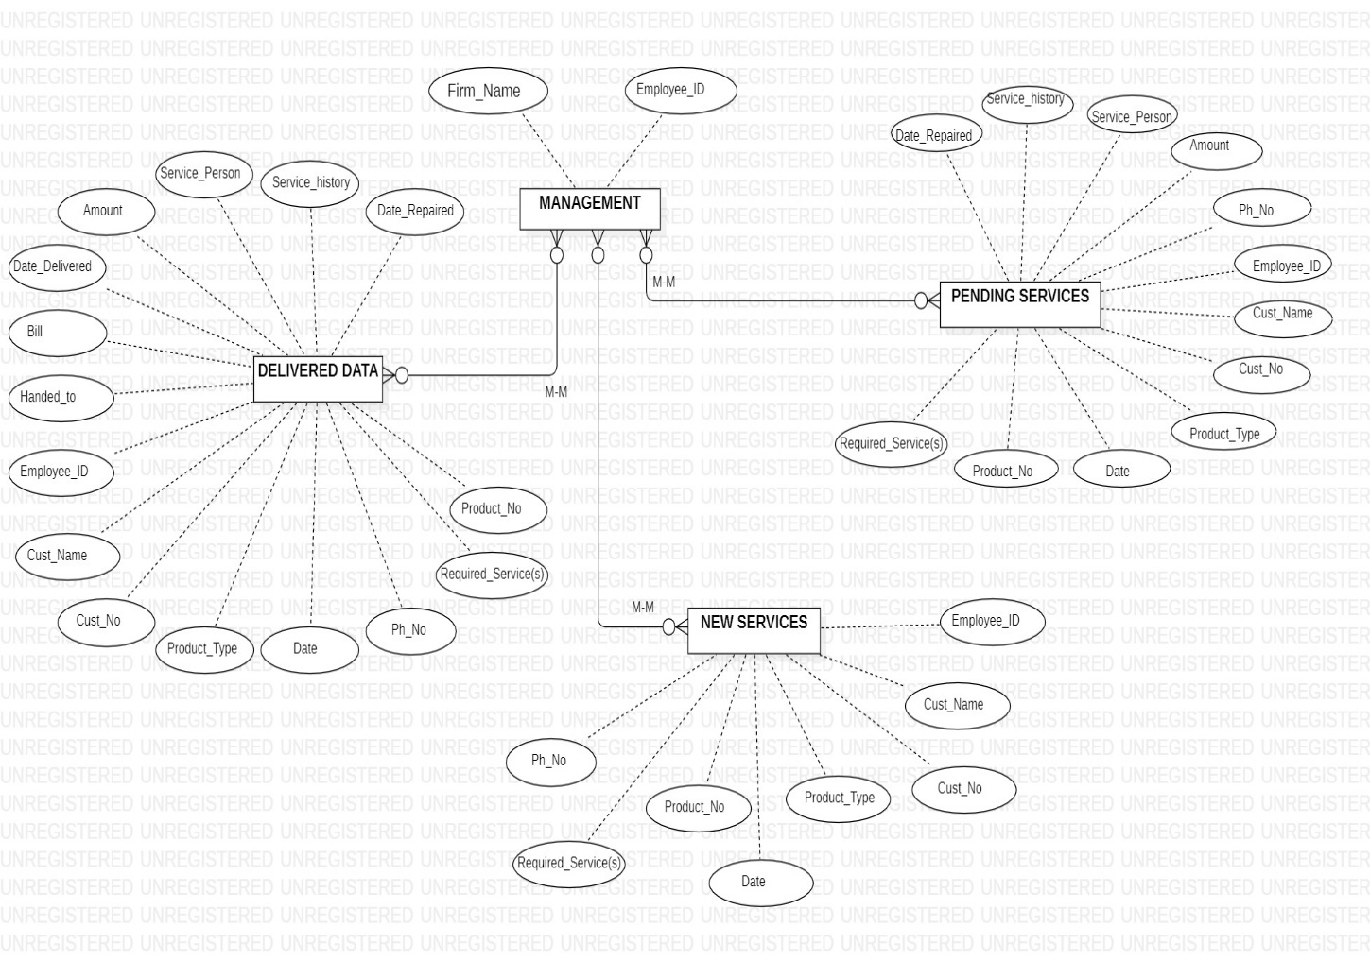

* Use Case Diagram

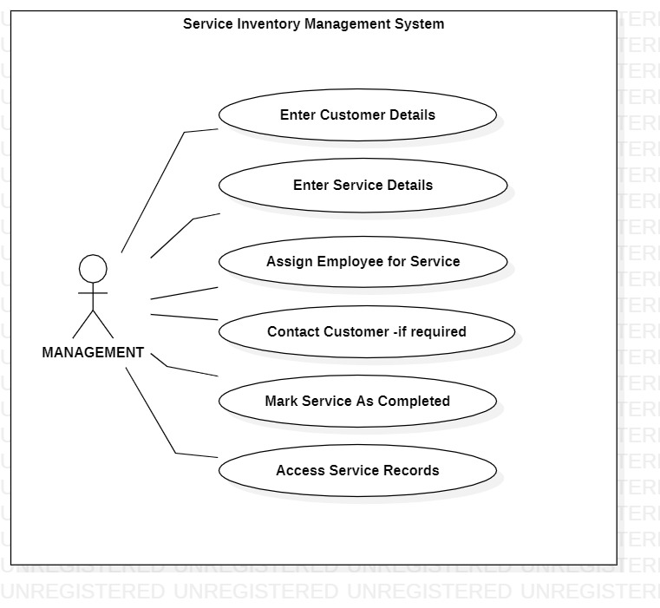

* Class Diagram

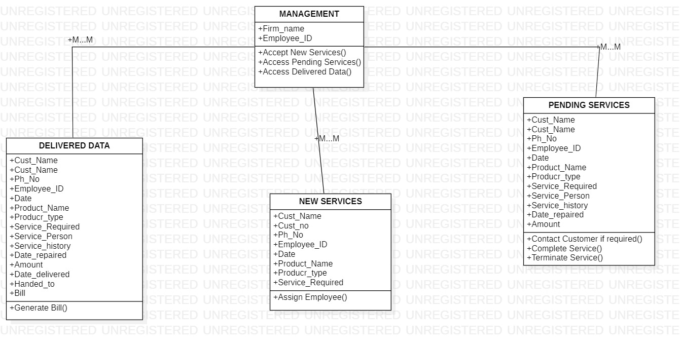

* State Diagram

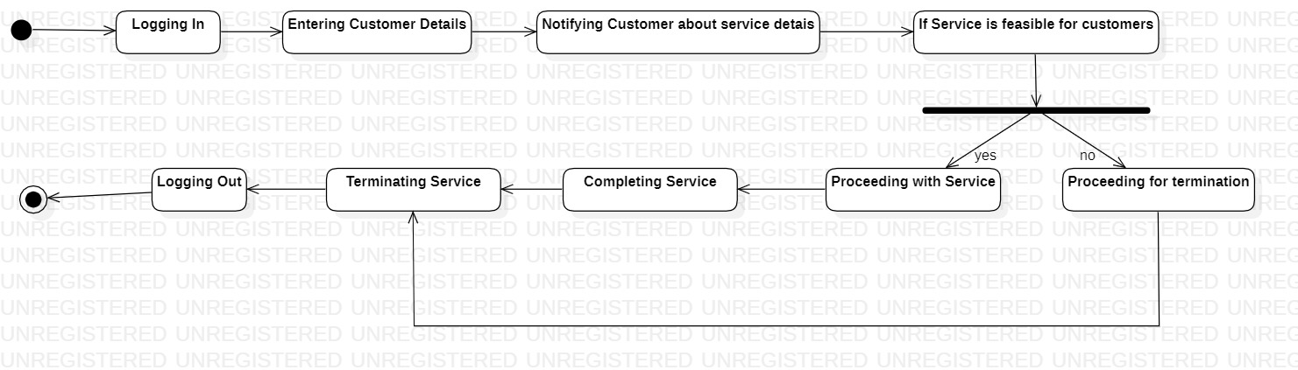

* Activity Diagram

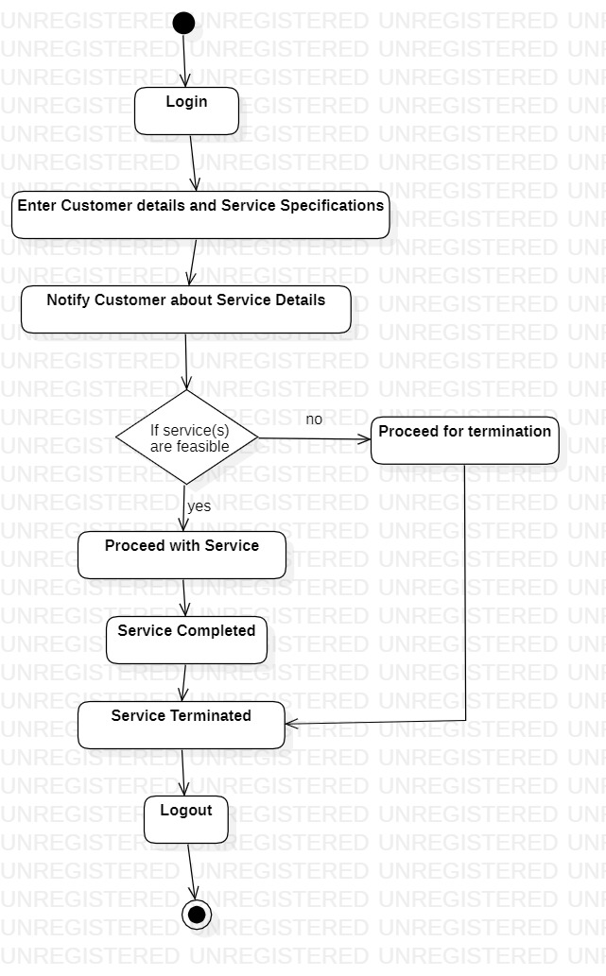

**3.3 Table Design**

1. **Management**

**Employee Details**

|  |  |  |  |  |
| --- | --- | --- | --- | --- |
| Field Name | Data Type | Field Length | Constraints | Description |
| Employee_ID | Varchar | 15 | **Primary Key** | Employee ID |
| Emp_Name | Varchar | 25 | Not null | Employee Name |
| Emp_Age | Int | 5 | Not null | Employee Age |
| Emp_Des | Varchar | 25 | Not null | Employee Designation |
| Emp_Salary | Int | 15 | Not null | Employee Salary |
| Emp_email | Varchar | 25 | Not null | Employee Email ID |
| Emp_Address | Varchar | 25 | Not null | Employee Email ID |
| Emp_DOB | Date | 10 | Not null | Employee DOB |
| Emp_Phno | Int | 10 | Not null | Employee Phone Number |

**Customer Records**

|  |  |  |  |  |
| --- | --- | --- | --- | --- |
| Field Name | Data Type | Field Length | Constraints | Description |
| Cust_Name | Varchar | 25 | Not null | Customer Name |
| Cust_No | Varchar | 8 | **Primary Key** | Customer Number |
| Ph_No | Int | 10 | Not null | Customer phone number |
| Employee_ID | Varchar | 15 | **Foreign Key** | Employee ID |
| Date | Date | 10 | Not null | Date of Service Requirement |
| Product_Name | Varchar | 30` | Not null | Product Name |
| Product_No | Varchar | 20 | Not null | Product Number |
| Service_Required | Varchar | 30 | Not null | Type of Service Required |
| Service_history | Varchar | 30 | Not null | All of the services history |
| Date_repaired | Date | 10 | Not null | Date of service repair |
| Amount | Int | 10 | Not null | Cost of the provide service(s) |
| Date_delivered | Date | 10 | Not null | Date of delivery |
| Handed_to | Varchar | 20 | Not null | Name of the person handed-to |
| Bill | Varchar | 50 | Not null | Total bill of the provided service |

**3.4 Screen Shots**

**Old User Interface**

**Login Page**

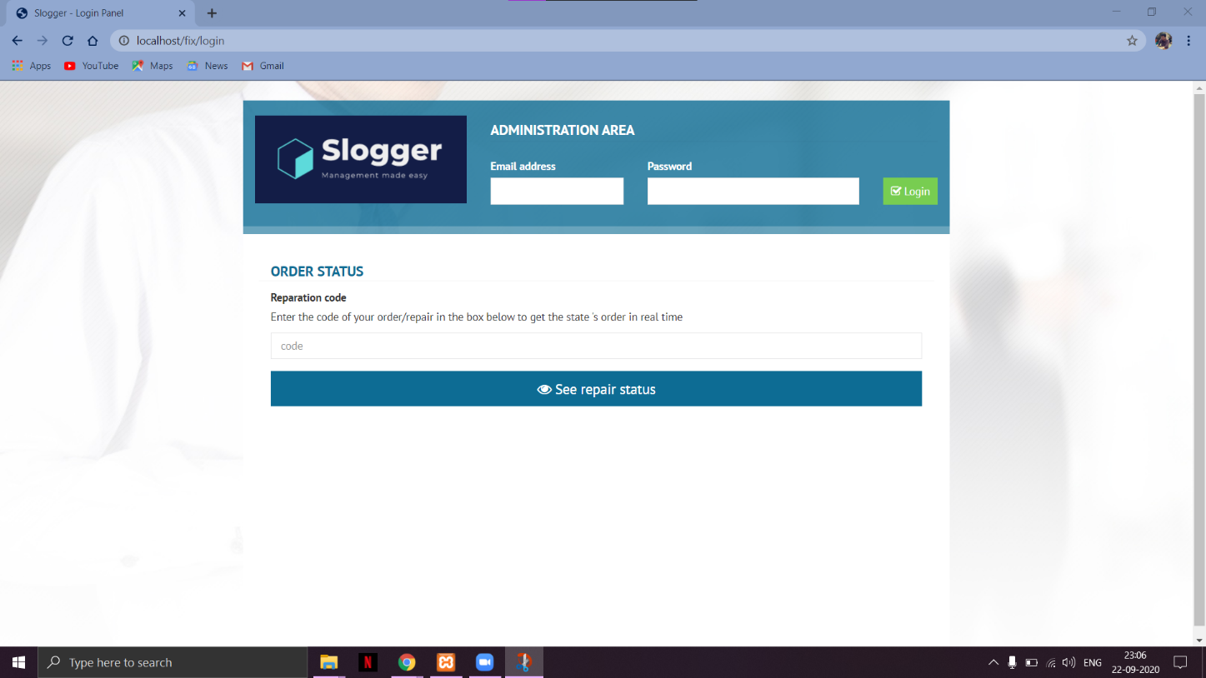

**Home Page**

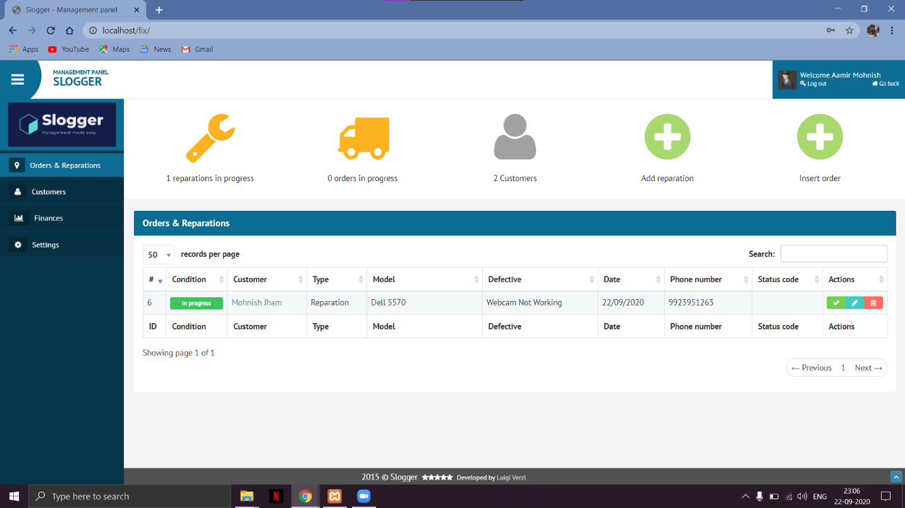

**Add New Service Record**

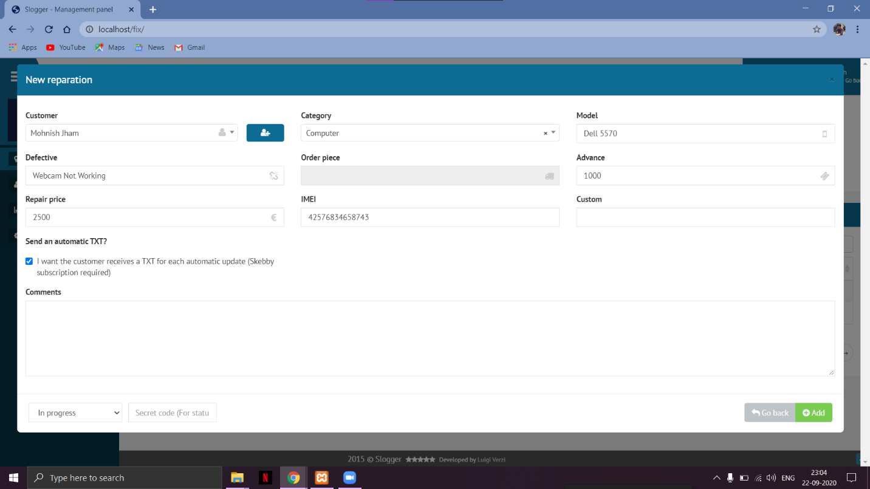

**Customer Records**

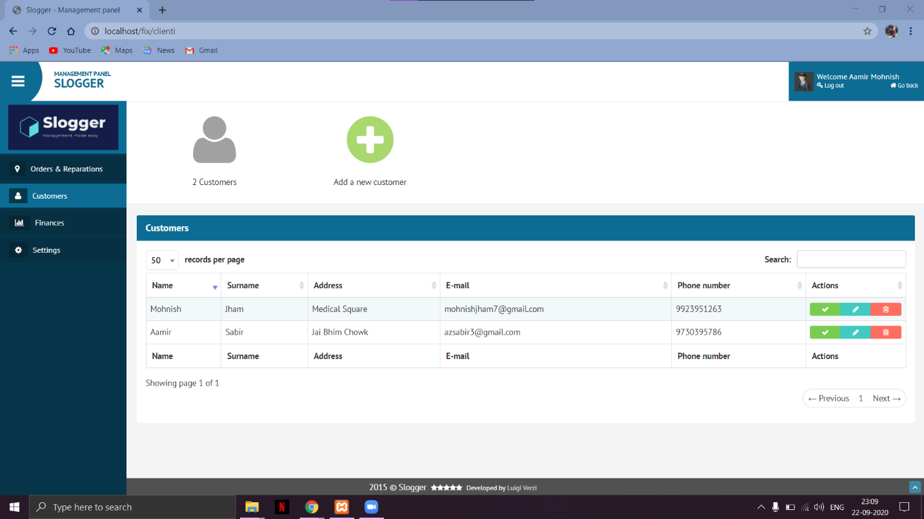

**Modular Settings**

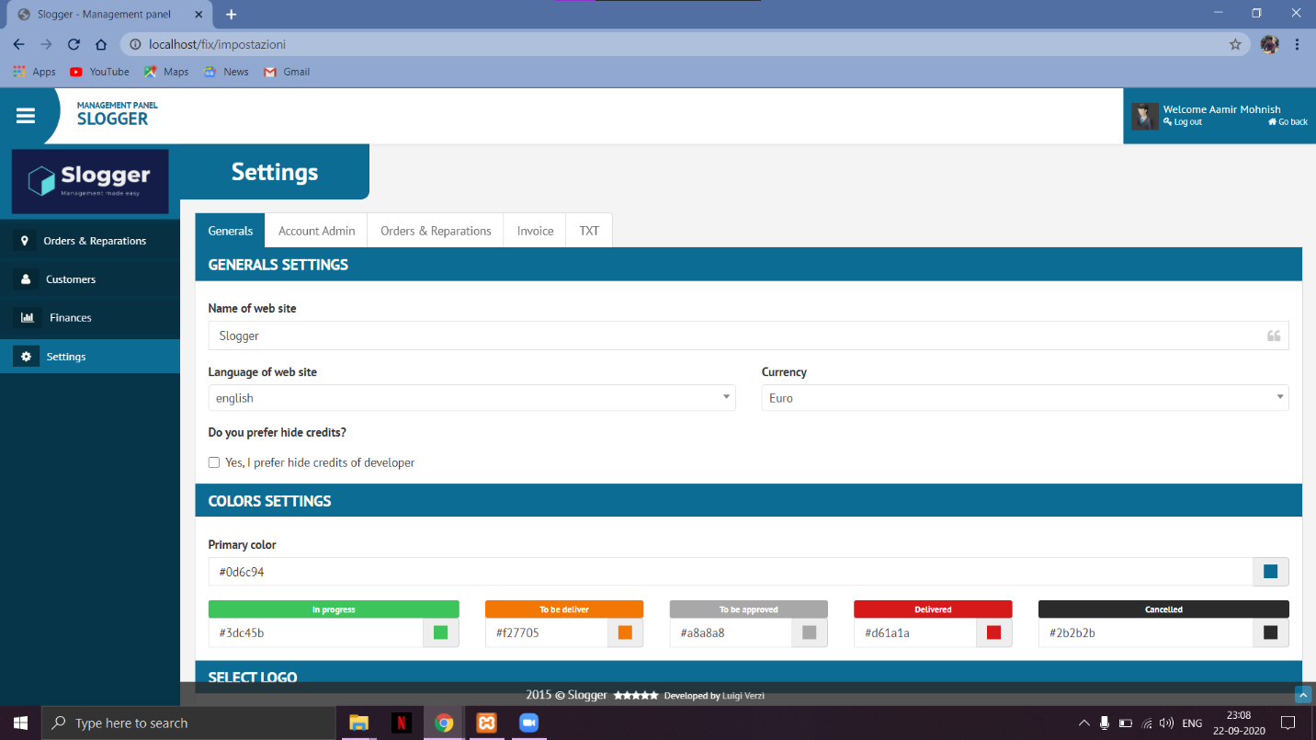

**New User Interface and Design**

**Login Page**

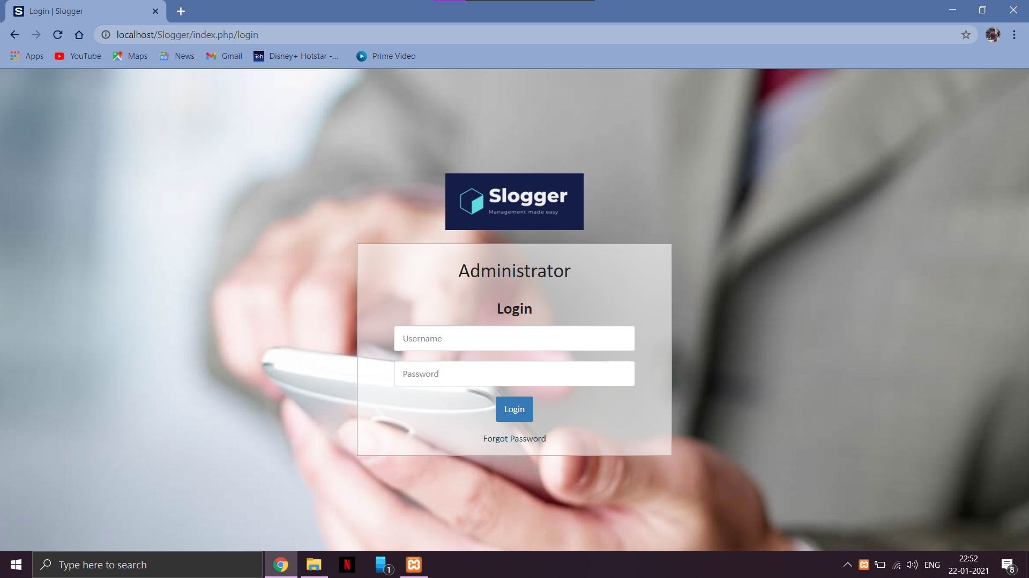

**Dashboard**

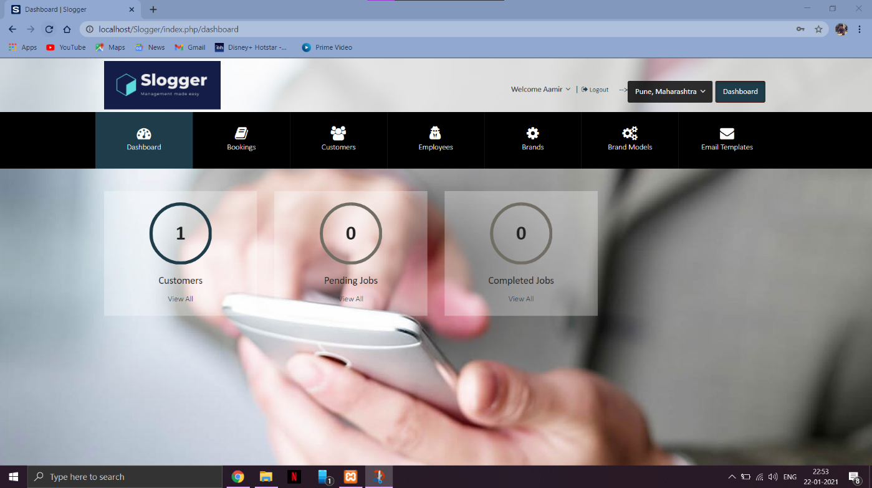

**Bookings**

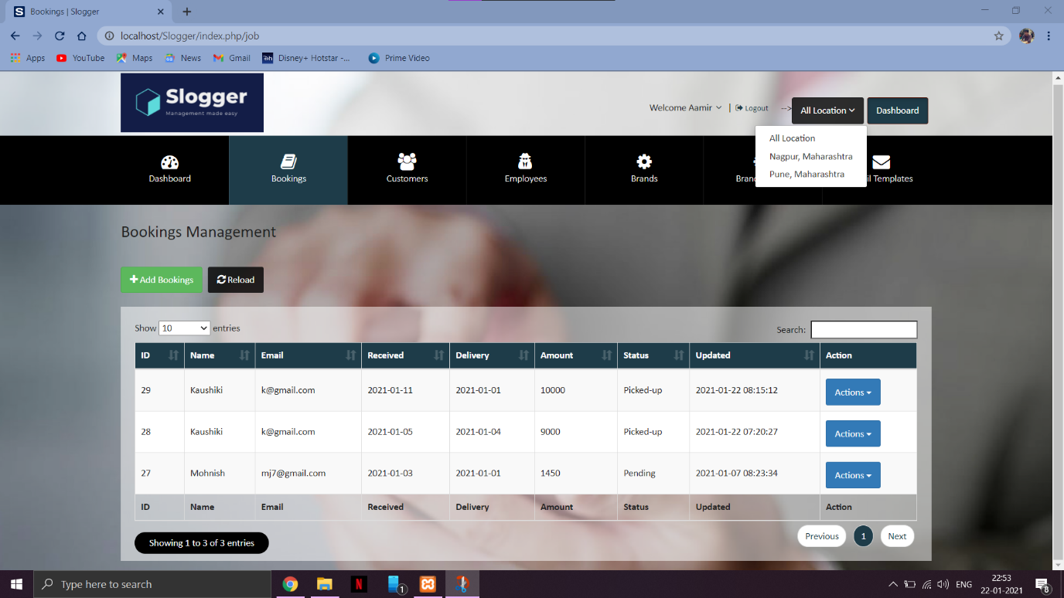

**Customer Page**

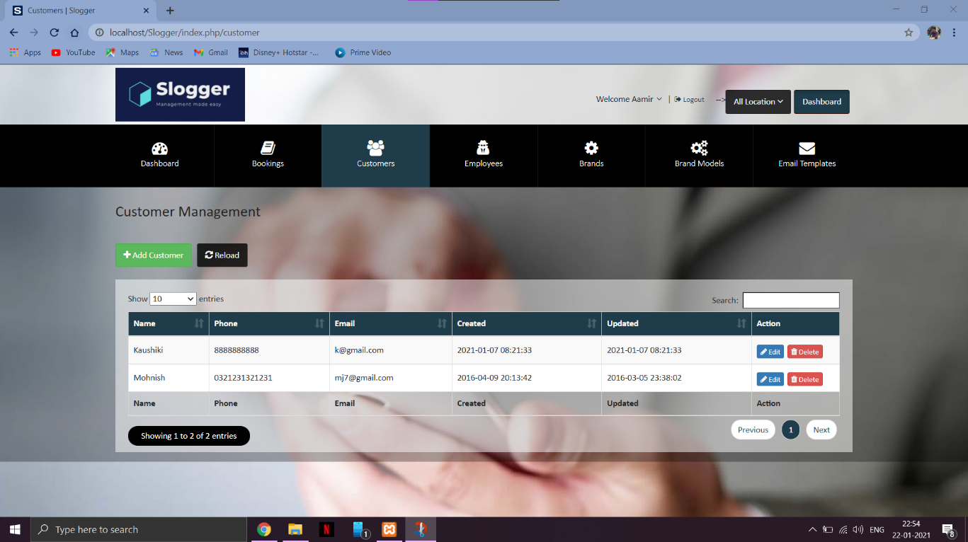

**Admin Page**

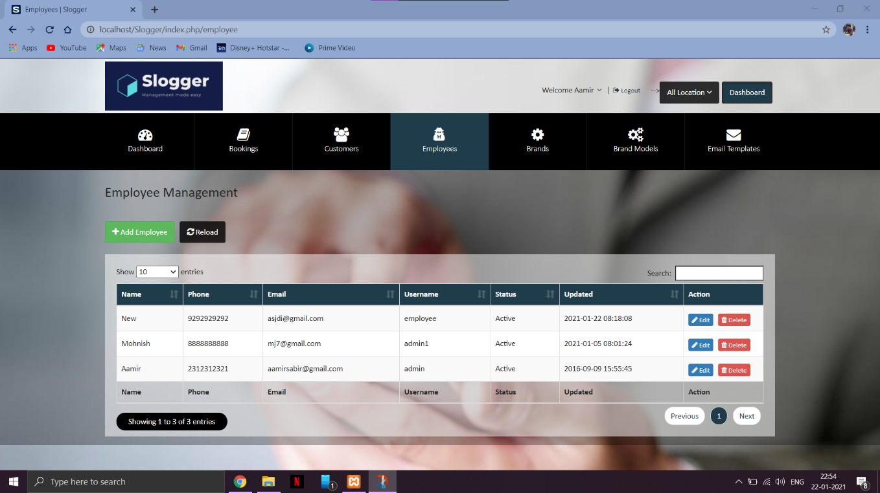

**Brands Page**

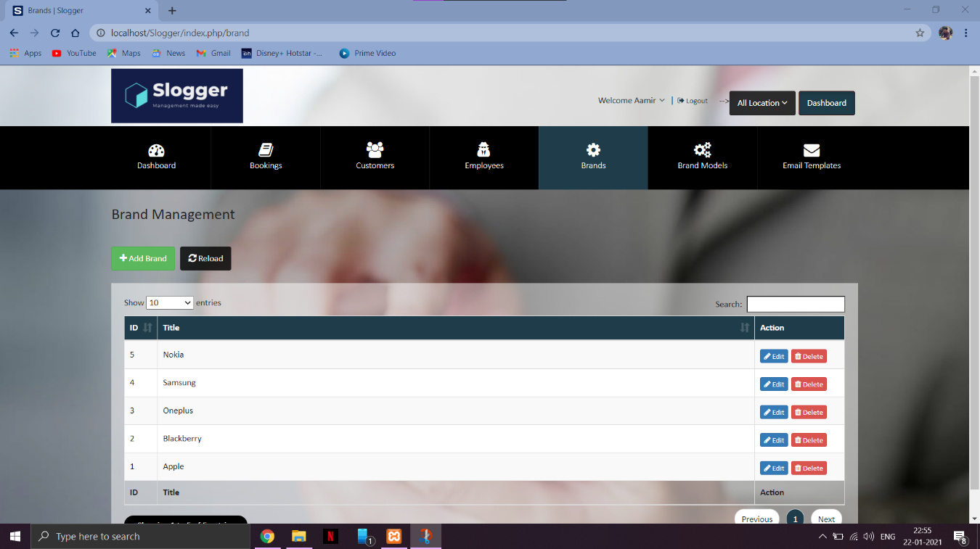

**Automatic Email Templates**

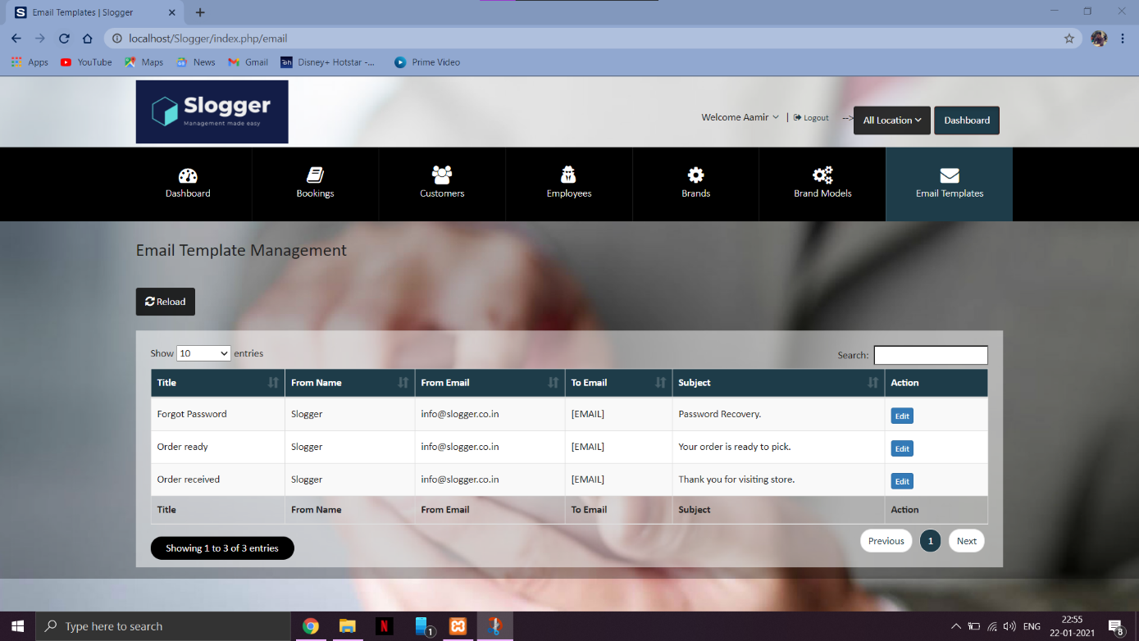

**Chapter 4**

* 1. **User Manual**

1. Login through the given id and password.
2. To add a new customer click on the customer tab on the left hand side; click "Add New"; fill up customer details and press ok.
3. To add a new service record click on "Add New" and fill the details of the service as required.
4. The ongoing services are visible on the home page as a table.
5. You can edit , delete or mark as complete an existing service at the right of the table where the records are displayed.
6. An automated invoice will be generated when the service is marked as complete and a text message will be forward to the customer notifying the same.

**Chapter 5**

* 1. **Future Enhancements**
* The project has been created keeping the future needs of the users in mind. The modularity of the software allows it to be customisable and easily accessible to any type of requirements, current or future.
* Online payment system can be added.
* Before-After pictures can be taken.
  1. **Disadvantages**
* Although the site's interface is really user friendly, the lesser techno savvy in the customer base may experience a bit trouble while operating at first but would eventually be adjusted to it.
* The users without any backup power supply may have problems during the time of a power outage
  1. **Conclusion**
* To conclude, Slogger is a simple desktop based application basically suitable for small organization. It has every basic items which are used for the small organization. Our team is successful in making the application where we can update, insert and delete the item as per the requirement.
* It also gives the customer a look into the process and enables them to be able to get the status of the service that is currently in progress.
* Through it has some limitations, our team strongly believes that the implementation of this system will surely benefit the organization.